Question
Write an Embedded C application integrating ADC, UART, and GPIO using structured programming
Aim
To develop an Embedded C application using structured programming that integrates ADC (Analog-to-Digital Converter) for analog signal acquisition, UART (Universal Asynchronous Receiver/Transmitter) for serial communication, and GPIO (General Purpose Input/Output) for controlling input/output devices, enabling efficient data acquisition, processing, and communication in an embedded system.
Requirements Analysis
Functional Requirements
- Initialize the ADC, UART, and GPIO peripherals.
- Read analog input values using the ADC.
- Convert the analog signal into a digital value.
- Transmit ADC data through UART.
- Receive commands or data through UART.
- Control GPIO devices (LED/Switch) based on received data or ADC values.
- Display ADC readings and communication status.
- Detect communication errors and handle invalid data gracefully.
Non-Functional Requirements
- Reliability: Ensure accurate ADC conversion and dependable UART communication.
- Real-Time Performance: Read and transmit data with minimal delay.
- Efficiency: Minimize CPU and memory usage during execution.
- Maintainability: Use structured and modular programming for easy modification.
- Scalability: Support the addition of more ADC channels and GPIO devices.
- Portability: The Embedded C program should be adaptable to different microcontrollers.
- Robustness: Handle communication errors and invalid inputs without system failure.
- Low Power Consumption: Optimize peripheral usage for energy-efficient operation.

Block Diagram
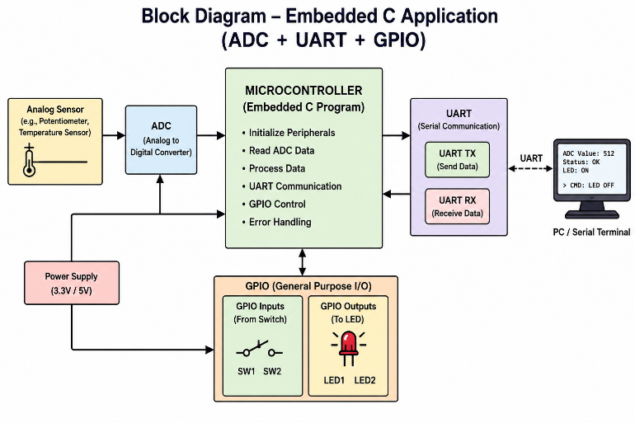
Algorithm
- Initialize the ADC, UART, and GPIO peripherals.
- Read the analog input using the ADC.
- Convert the analog signal into a digital value.
- Display the ADC value.
- Transmit the ADC value through UART.
- Receive data or commands through UART.
- Control the GPIO (LED) based on the received command or ADC value.
- Repeat the process continuously.
Embedded C Program
#include <stdio.h>

int adcValue = 512;
char uartData = '1';

void ADC_Init()
{
printf("ADC Initialized\n");
}

int ADC_Read()
{
return adcValue;
}

void UART_Init()
{
printf("UART Initialized\n");
}

void UART_Send(int data)
{
printf("UART TX : ADC Value = %d\n", data);
}

char UART_Receive()
{
return uartData;
}

void GPIO_Control(char data)
{
if(data == '1')
printf("LED ON\n");
else
printf("LED OFF\n");
}

int main()
{
int value;

ADC_Init();
UART_Init();

value = ADC_Read();
printf("ADC Value : %d\n", value);

UART_Send(value);

uartData = UART_Receive();
GPIO_Control(uartData);

return 0;
}
Sample Output
ADC Initialized
UART Initialized
ADC Value : 512
UART TX : ADC Value = 512
LED ON
TEST CASE
Test Case | Expected Result | Status
Valid ADC Input | ADC value displayed | Pass
UART Transmission | ADC value transmitted | Pass
UART Receive = '1' | LED ON | Pass
UART Receive = '0' | LED OFF | Pass
Advantages
- Simple and modular program structure.
- Efficient integration of ADC, UART, and GPIO.
- Easy to understand and maintain.
- Suitable for real-time embedded applications.
- Easily expandable for additional peripherals.

Conclusion
The Embedded C application successfully integrates ADC, UART, and GPIO using a structured programming approach. The system acquires analog data, communicates it through UART, and controls GPIO devices based on received commands, making it suitable for embedded monitoring and control applications.
Question
- Design an Embedded C firmware for an industrial HVAC controller integrating sensors and actuators with modular code organization.
Aim
To design and develop an Embedded C firmware for an Industrial HVAC (Heating, Ventilation, and Air Conditioning) Controller that integrates temperature and humidity sensors with actuators such as fans and cooling/heating units using a modular code organization, enabling efficient environmental monitoring and automatic climate control.
Requirements Analysis
Functional Requirements
- Read temperature and humidity sensor data.
- Monitor environmental conditions continuously.
- Control cooling, heating, and ventilation actuators.
- Turn actuators ON/OFF based on preset threshold values.
- Display the current sensor readings and actuator status.
- Ensure safe operation by preventing abnormal temperature conditions.
Non-Functional Requirements
- Reliable environmental monitoring.
- Fast response to changing temperature and humidity.
- Modular and maintainable Embedded C code.
- Low power consumption.
- Scalable for additional sensors and actuators.
Block Diagram

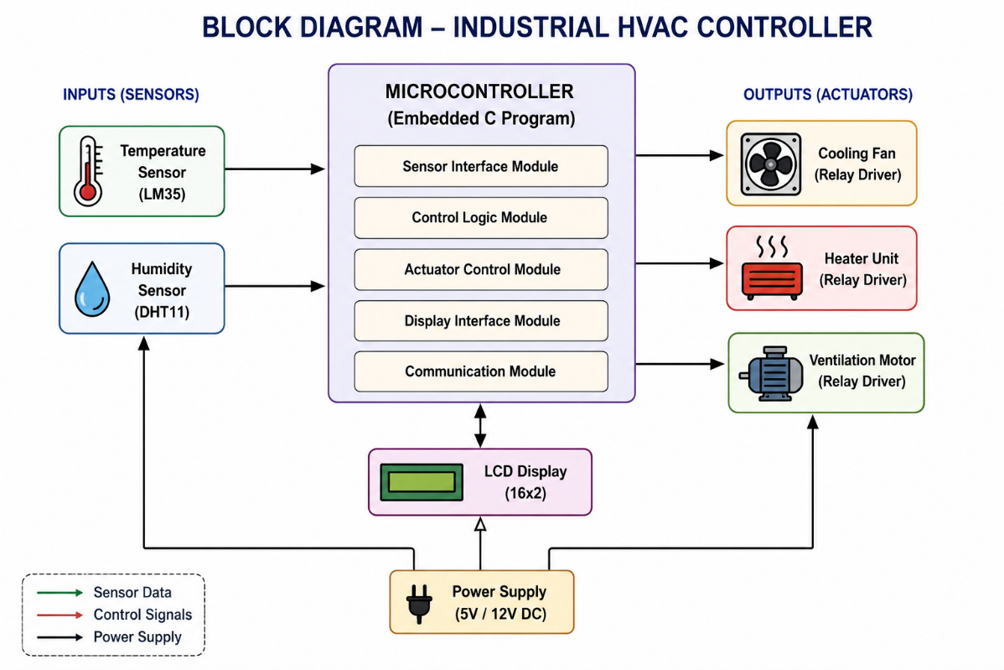

Algorithm
- Initialize the temperature and humidity sensors.
- Read the sensor values.
- Compare the values with predefined threshold limits.
- If the temperature is high, turn ON the cooling fan.
- If the temperature is low, turn ON the heater.
- Control the ventilation motor based on humidity level.
- Display the sensor readings and actuator status.
- Repeat the process continuously.
Embedded C Program
#include <stdio.h>

int temperature = 30;
int humidity = 65;

void ReadSensors()
{
printf("Temperature = %d C\n", temperature);
printf("Humidity = %d %%\n", humidity);
}

void ControlHVAC()
{
if(temperature > 28)
printf("Cooling Fan : ON\n");
else
printf("Cooling Fan : OFF\n");

if(temperature < 20)
printf("Heater : ON\n");
else
printf("Heater : OFF\n");

if(humidity > 60)
printf("Ventilation : ON\n");
else
printf("Ventilation : OFF\n");
}

int main()
{
printf("Industrial HVAC Controller\n\n");

ReadSensors();
ControlHVAC();

return 0;
}

Sample Output
Industrial HVAC Controller
Temperature = 30 C
Humidity = 65 %
Cooling Fan : ON
Heater : OFF
Ventilation : ON
Test Cases
Test Case | Expected Result | Status
Temperature > 28°C | Cooling Fan ON | Pass
Temperature < 20°C | Heater ON | Pass
Humidity > 60% | Ventilation ON | Pass
Normal Conditions | Appropriate actuator operation | Pass

Advantages
- Automatic climate control.
- Improved energy efficiency.
- Modular and reusable code.
- Reliable industrial operation.
- Easy integration with additional sensors.
Conclusion
The Embedded C firmware successfully implements an Industrial HVAC Controller using a modular code organization. The system continuously monitors temperature and humidity, controls the cooling fan, heater, and ventilation unit automatically, and provides an efficient and reliable solution for industrial environmental control.

